LAB #8

Troubleshoot apps on Azure Kubernetes Service
In this exercise, you deploy a containerized API to Azure Kubernetes Service (AKS) and then diagnose and resolve common Kubernetes issues. You use kubectl commands to identify problems, inspect pod status, check logs, and view events. You then use kubectl edit to fix misconfigurations including Service selector mismatches, missing environment variables, and invalid readiness probe paths.
Tasks performed in this exercise:
- Download the project starter files
- Deploy resources to Azure (ACR, AKS cluster)
- Diagnose and resolve some common issues
- Clean up Azure resources
This exercise takes approximately 30 minutes to complete.
Important: Azure Container Registry task runs are temporarily paused from Azure free credits. This exercise requires a Pay-As-You-Go, or another paid plan.
Before you start
To complete the exercise, you need:
- An Azure subscription with the permissions to deploy the necessary Azure services. If you don't already have one, you can sign up for one.
- Visual Studio Code on one of the supported platforms.
- The latest version of the Azure CLI.
- The Kubernetes command-line tool, kubectl.
- Optional: Python 3.12 or greater.
Download project starter files and deploy Azure services
In this section you download the starter files for the console app and use a script to deploy the necessary services to your Azure subscription. The Azure resource deployments can take 10-15 minutes to complete.
- Open a browser and enter the following URL to download the starter file. The file will be saved in your default download location.
TypeCopy
https://github.com/MicrosoftLearning/mslearn-azure-ai/raw/main/downloads/python/aks-troubleshoot-python.zip
- Copy, or move, the file to a location in your system where you want to work on the project. Then unzip the file into a folder.
- Launch Visual Studio Code (VS Code) and select File > Open Folder… in the menu, then choose the folder containing the project files.
- The project contains deployment scripts for both Bash (azdeploy.sh) and PowerShell (azdeploy.ps1). Open the appropriate file for your environment and change the two values at the top of the script to meet your needs, then save your changes. Note: Do not change anything else in the script.
TypeCopy
$rg = "ResourceGroup1" # Resource Group name
$location = "<your-azure-region>" # Azure region for the resources
- In the menu bar select Terminal > New Terminal to open a terminal window in VS Code.
- Run the following command to login to your Azure account. Answer the prompts to select your Azure account and subscription for the exercise.
TypeCopy
az login
- Run the following commands to ensure your subscription has the necessary resource providers to install AKS and ACR. The Microsoft.Compute, Microsoft.Network, and Microsoft.Storage providers are dependencies of AKS that Azure usually registers automatically, but explicitly registering them avoids occasional cluster creation failures on new subscriptions.
TypeCopy
az provider register --namespace Microsoft.ContainerService
az provider register --namespace Microsoft.ContainerRegistry
az provider register --namespace Microsoft.Compute
az provider register --namespace Microsoft.Network
az provider register --namespace Microsoft.Storage
- Make sure you are in the root directory of the project and run the appropriate command in the terminal to launch the deployment script.
Bash
bashTypeCopy
bash azdeploy.sh
PowerShell
powershellTypeCopy
./azdeploy.ps1
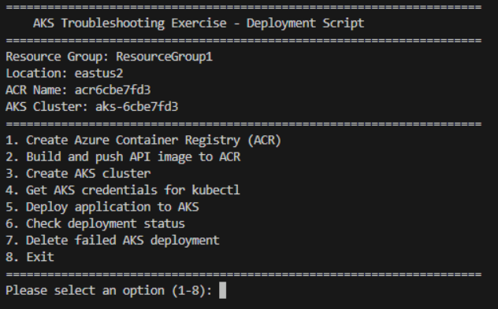
Note: If PowerShell blocks the script because it is not digitally signed, run the following command in the same terminal session, then run the deployment script again. This command changes the execution policy only for the current PowerShell process.
powershellTypeCopy
Set-ExecutionPolicy -Scope Process -ExecutionPolicy Bypass
Deploy resources to Azure
With the deployment script running, follow these steps to create the needed resources in Azure.
- Enter 1 to launch Create Azure Container Registry (ACR). This creates the resource where the API container will be stored, and later pulled into the AKS resource.
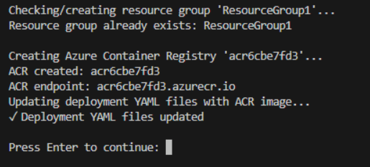
- After the ACR resource has been created, enter 2 to launch Build and push API image to ACR. This option uses ACR tasks to build the image and add it to the ACR repository. This operation can take 3-5 minutes to complete.
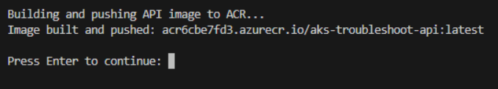
- After the image has been built and pushed to ACR, enter 3 to launch the Create AKS cluster option. This creates the AKS resource configured with a managed identity, and gives the service permission to pull images from the ACR resource.
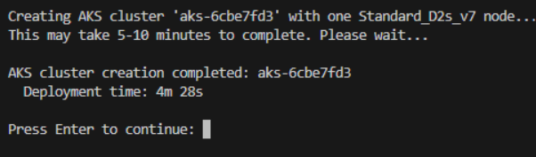
- After the AKS cluster deployment has completed, enter 4 to launch the Get AKS credentials for kubectl option. This uses the az aks get-credentials command to retrieve credentials and configure kubectl.
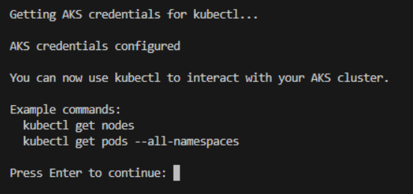
- After the credentials have been set, enter 5 to launch the Deploy applications to AKS option. This deploys an API to the AKS cluster.
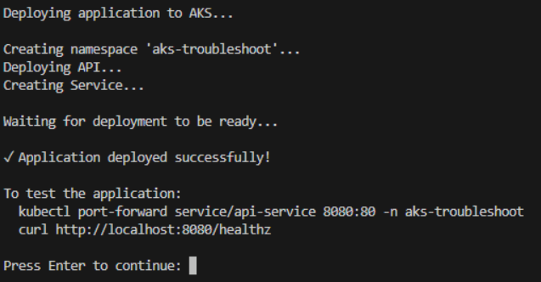
- After the app has been deployed, enter 6 to launch the Check deployment status option. This option reports if each of the resources have been successfully deployed.
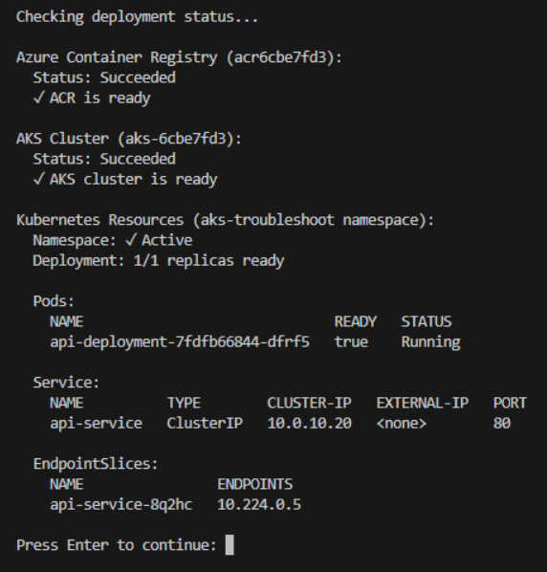
If all of the services return a successful message, enter 8 to exit the deployment script.
If the AKS cluster is in a Failed or Canceled state, correct the reported issue, then enter 7 to launch the Delete failed AKS deployment option before running option 3 again. This guarded option does not delete a healthy or in-progress cluster.
Note: Leave the terminal open, all of the steps in the exercise are performed in the terminal.
Troubleshoot the deployment
The deployment script created all Kubernetes resources in a namespace called aks-troubleshoot. Namespaces are a way to organize and isolate resources within a Kubernetes cluster. They allow you to group related resources together, apply resource quotas, and manage access control. When you don't specify a namespace, resources are created in the default namespace. For this exercise, all kubectl commands include -n aks-troubleshoot to target the correct namespace.
After you verify the deployment, you work through three troubleshooting scenarios. In each scenario, you apply a manifest file that introduces a specific error into the deployment. Then you use kubectl commands to diagnose the problem and edit the configuration to resolve it.
Verify the deployment
In this section you confirm the application deployed by the setup script is running correctly before introducing errors.
- Run the following command to verify the pod is running in the namespace. The command should return one pod with Running status and 1/1 in the READY column.
TypeCopy
kubectl get pods -n aks-troubleshoot
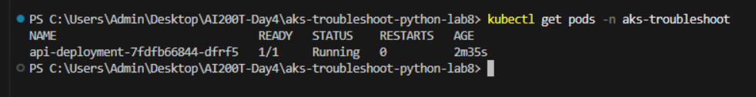
- Run the following command to verify the Service has endpoints. The command should return one endpoint slice listed with an IP address.
TypeCopy
kubectl get endpointslices -l kubernetes.io/service-name=api-service -n aks-troubleshoot
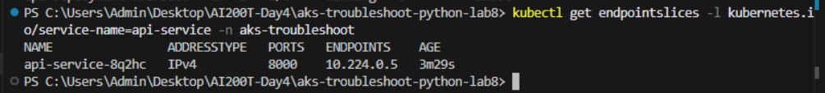
- Run the following command to test connectivity using port-forward. This command creates a tunnel from your local machine to the Service running in the cluster, allowing you to access it at http://localhost:8080.
TypeCopy
kubectl port-forward service/api-service 8080:80 -n aks-troubleshoot
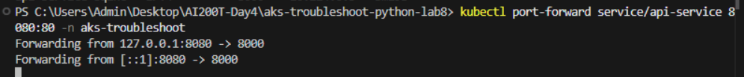
- In the menu bar select Terminal > New Terminal to open a second terminal window in VS Code. Run the following command to test the connection. You should receive a JSON response with "status": "healthy".
bashTypeCopy
# Bash
curl http://localhost:8080/healthz
powershellTypeCopy
# PowerShell
Invoke-RestMethod http://localhost:8080/healthz
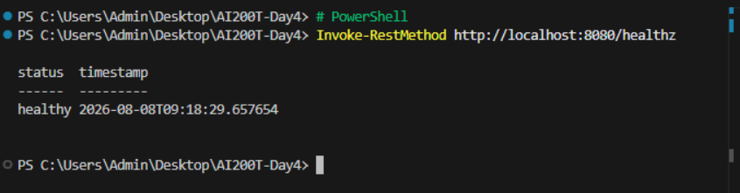
- Switch back to the terminal where port-forward is running and enter ctrl+c to exit the command.
You verified the deployment is working correctly, next you diagnose a label mismatch issue.
Diagnose a label mismatch
A Service routes traffic to pods based on label selectors. When labels don't match, the Service has no endpoints and requests fail. The API was deployed with pods labeled app: api and a Service selector matching app: api. In this section you apply a Service configuration that changes the selector to app: api-v2, breaking the connection.
- Run the following command to apply the Service configuration that creates a label mismatch error.
TypeCopy
kubectl apply -f k8s/label-mismatch-service.yaml -n aks-troubleshoot
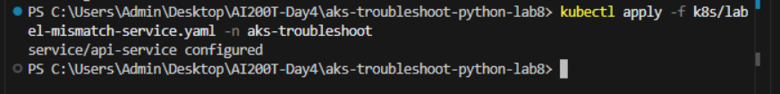
- Run the following command to verify the pod is still running. The pod shows Running status with 1/1 ready and labels showing app=api.
TypeCopy
kubectl get pods --show-labels -n aks-troubleshoot
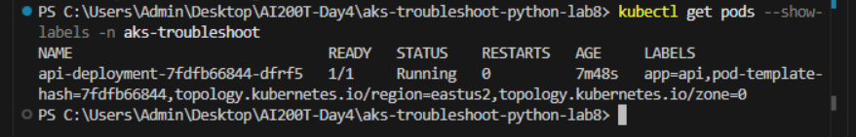
- Run the following command to check the Service endpoint slices. The command should return an endpoint slice with \ in the ENDPOINTS column, indicating no pods match the Service selector.
TypeCopy
kubectl get endpointslices -l kubernetes.io/service-name=api-service -n aks-troubleshoot
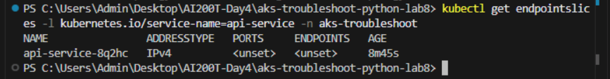
- Run the following command to view the Service details. Look for the Selector field in the output, which now shows app=api-v2.
TypeCopy
kubectl describe service api-service -n aks-troubleshoot
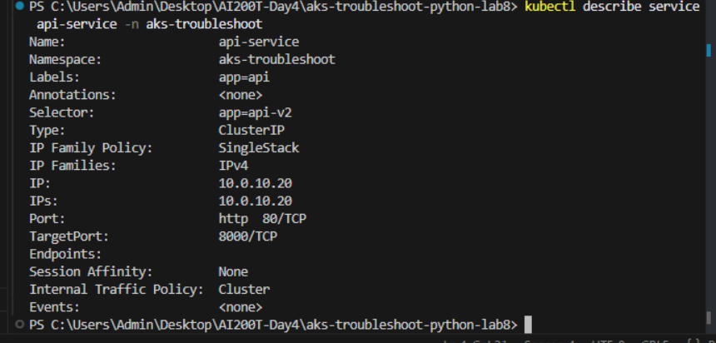
This confirms the label mismatch. The Service selector is app=api-v2 but the pod label is app=api.
- Run the following command to open the Service configuration in an editor.
TypeCopy
kubectl edit service api-service -n aks-troubleshoot
Note: The kubectl edit command fetches the live resource configuration from the cluster and opens it in a local text editor. When you save and close the editor, kubectl automatically sends the changes back to the Kubernetes API server, which validates and applies them to the running cluster. The editor depends on your environment:
  - Bash: Opens vi by default. Press i to enter insert mode, make your changes, press Esc, then type :wq and press Enter to save and exit. Type :q! to exit without saving.
  - PowerShell (Windows): Opens Notepad by default. Make your changes, select File > Save (or Ctrl+S), then close the window. Closing without saving cancels the edit.
- In the editor, find the selector section and change app: api-v2 to app: api. Save the changes and close the editor.
- Run the following command to verify the endpoint slice addresses are restored. The command should return an endpoint slice with an IP address listed.
TypeCopy
kubectl get endpointslices -l kubernetes.io/service-name=api-service -n aks-troubleshoot
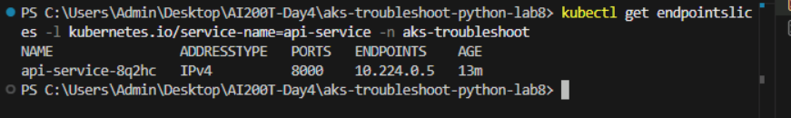
You fixed the label mismatch issue, next you diagnose a CrashLoopBackOff.
Diagnose a CrashLoopBackOff
When a container fails to start, Kubernetes repeatedly restarts it, resulting in CrashLoopBackOff status. Reading logs reveals why the application crashed.
- Run the following command to apply the deployment configuration that removes the required API_KEY environment variable.
TypeCopy
kubectl apply -f k8s/crashloop-deployment.yaml -n aks-troubleshoot
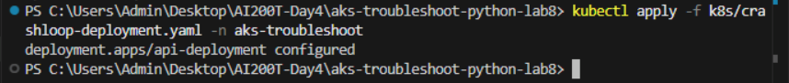
- Run the following command to watch the pod status. After a few moments, the pod enters CrashLoopBackOff. Enter ctrl-c to exit the command.
TypeCopy
kubectl get pods -n aks-troubleshoot -w
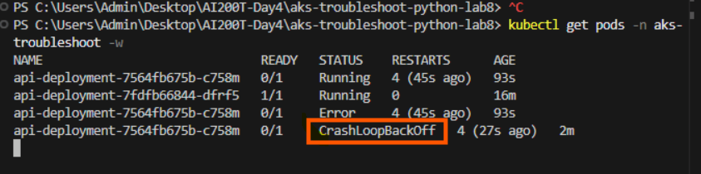
- Run the following command to check the pod logs for the error message. You should see an error indicating the missing environment variable.
TypeCopy
kubectl logs -l app=api -n aks-troubleshoot
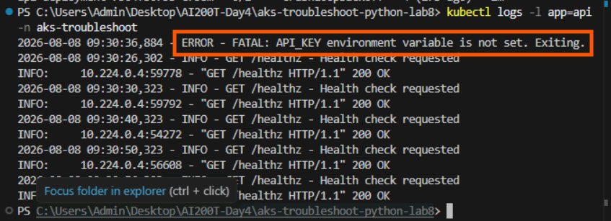
- Fix the issue by editing the Deployment to add the API_KEY environment variable.
TypeCopy
kubectl edit deployment api-deployment -n aks-troubleshoot
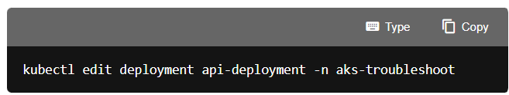

In the editor, find the containers section under spec.template.spec. Locate the name: api line and add the env block directly below it, matching the indentation of name:
yamlTypeCopy
name: api
env:
- name: API_KEY
value: "demo-api-key-12345"
ports:
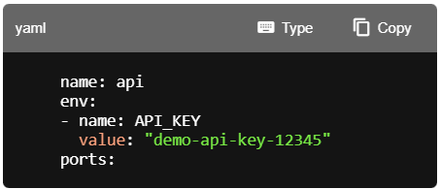
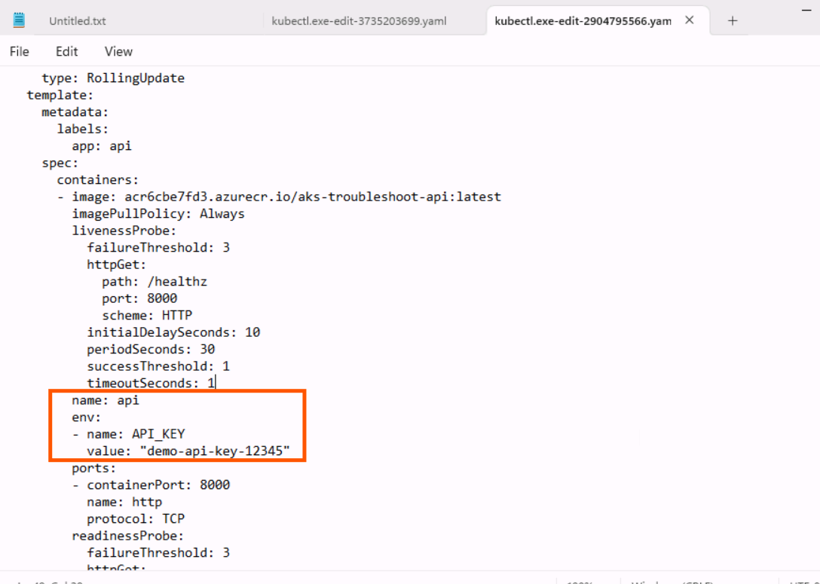
Save the changes and close the editor.
- Run the following command to watch the pod status. After a few moments, the pod enters Running. Enter ctrl-c to exit the command.
TypeCopy
kubectl get pods -n aks-troubleshoot -w
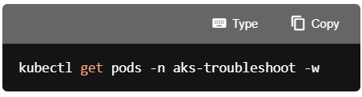
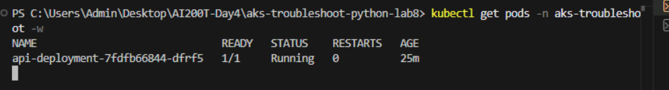
You solved the CrashLoopBackOff issue, next you diagnose a readiness probe failure.

Diagnose a readiness probe failure
When a readiness probe fails, the pod shows Running but 0/1 containers are ready. Kubernetes won't add the pod to Service endpoints until it passes the readiness check. With a rolling update strategy, the old working pod continues serving traffic while the new pod remains stuck in a not-ready state.
- Run the following command to apply the deployment configuration that introduces a readiness probe failure. This applies an invalid path for the readiness check.
TypeCopy
kubectl apply -f k8s/probe-failure-deployment.yaml -n aks-troubleshoot
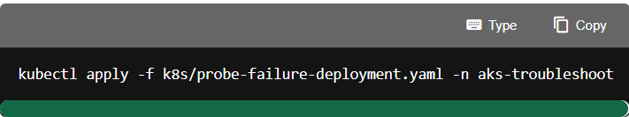
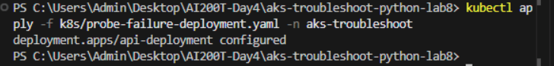
- Run the following command to check the pod status. You should see two pods: the new pod shows Running but 0/1 in the READY column, while the old pod remains 1/1 ready. The rolling update is blocked because the new pod never becomes ready.
TypeCopy
kubectl get pods -n aks-troubleshoot
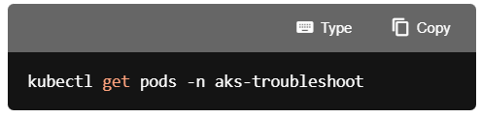
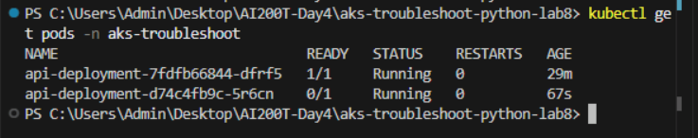
- Run the following command to check for probe failure events. The command returns all Unhealthy events, which include both readiness and liveness probe failures. Look for a message indicating the readiness probe failed with a 404 status code.
TypeCopy
kubectl get events -n aks-troubleshoot --field-selector reason=Unhealthy
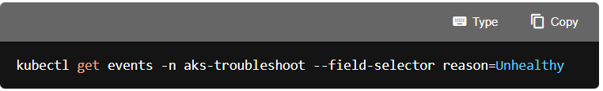
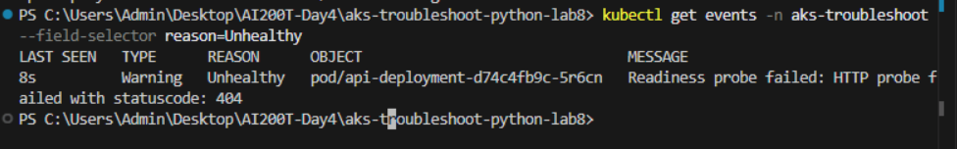
- Run the following command to fix the readiness probe by editing the Deployment to correct the path.
TypeCopy
kubectl edit deployment api-deployment -n aks-troubleshoot
In the editor, find the readinessProbe section and change path: /invalid-path to path: /healthz. Save the changes and close the editor.

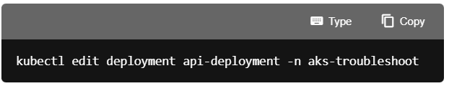
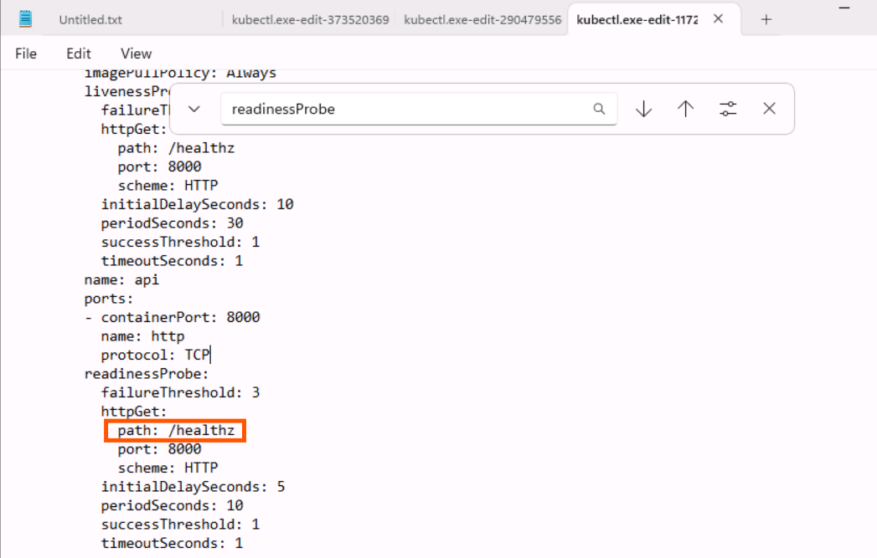

- Run the following command to verify the new pod becomes ready and the old pod terminates. You should see only one pod with Running status and 1/1 in the READY column.
TypeCopy
kubectl get pods -n aks-troubleshoot
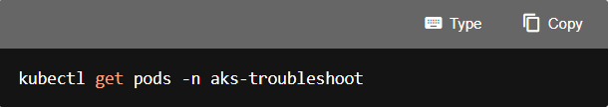
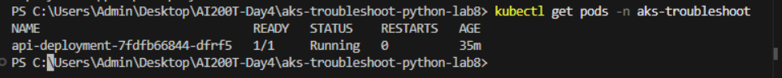

You diagnosed and solved a readiness probe error, next you verify end-to-end connectivity.
Verify end-to-end connectivity
After completing all troubleshooting scenarios, you confirm the application is fully functional.
- Run the following command to use port-forward to access the Service.
TypeCopy
kubectl port-forward service/api-service 8080:80 -n aks-troubleshoot
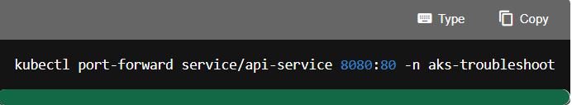
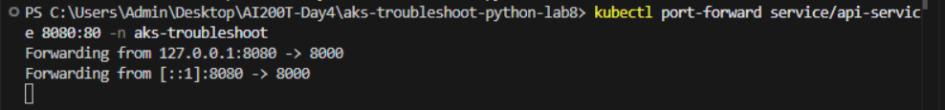
- In the menu bar select Terminal > New Terminal to open a second terminal window in VS Code. Run the following commands to test all endpoints.
bashTypeCopy
# Bash
curl http://localhost:8080/healthz
curl http://localhost:8080/readyz
curl http://localhost:8080/api/info
powershellTypeCopy
# PowerShell
Invoke-RestMethod http://localhost:8080/healthz
Invoke-RestMethod http://localhost:8080/readyz
Invoke-RestMethod http://localhost:8080/api/info
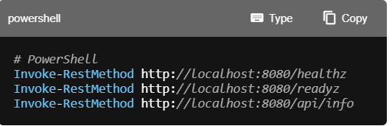
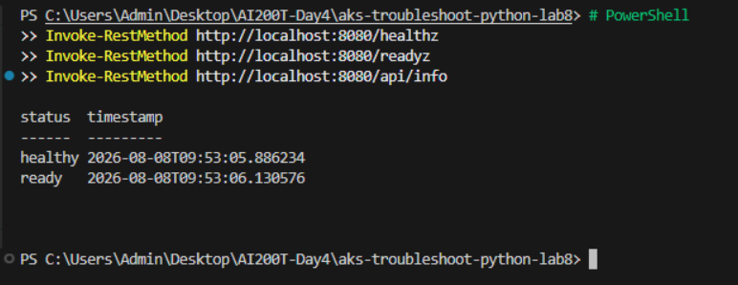
- Run the following command to check the pod logs to see the requests.
TypeCopy
kubectl logs -l app=api -n aks-troubleshoot
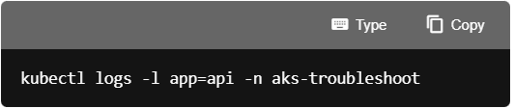
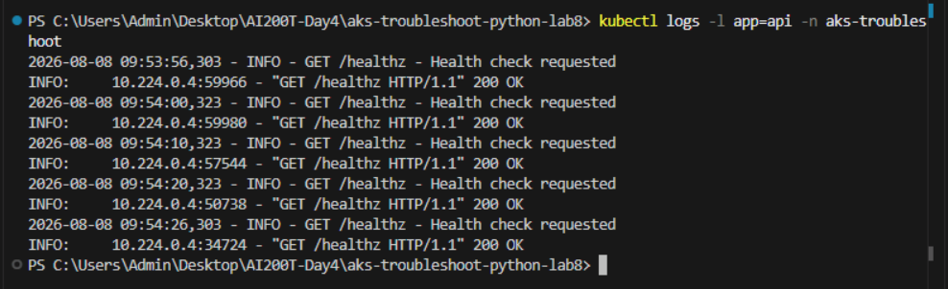

You verified the application is fully functional, next you clean up resources.
Clean up resources
Now that you finished the exercise, you should delete the cloud resources you created to avoid unnecessary resource usage.
- Run the following command in the VS Code terminal to delete the resource group, and all resources in the group. Replace \ with the name you choose earlier in the exercise. The command will launch a background task in Azure to delete the resource group.
TypeCopy
az group delete --name <rg-name> --no-wait --yes
CAUTION: Deleting a resource group deletes all resources contained within it. If you chose an existing resource group for this exercise, any existing resources outside the scope of this exercise will also be deleted.
Troubleshooting
If you encounter issues while setting up this exercise, try the following troubleshooting steps:
Check deployment status with the deployment script
- Run the deployment script and select option 6. Check deployment status to verify the state of all deployed resources.
- This command checks ACR provisioning state, AKS cluster provisioning state, and Kubernetes resource availability.
- Use this output to identify which component may be causing issues.
Resolve AKS cluster creation failures
- Quota validation can fail before an AKS resource is created, while failures later in provisioning can leave the cluster in a Failed or Canceled state.
- If the error reports that Standard_D2s_v5 is unavailable or that the region has insufficient capacity, exit with option 8, change the location value near the top of the deployment script, and run option 3. Create AKS cluster again.
- If the error reports insufficient quota, select a region where your subscription has available Dsv5-family quota or request a quota increase. Changing regions only helps when the other region has sufficient quota.
- The AKS cluster uses the location configured in the script even when the resource group already exists in another region.
- If option 6 reports Failed or Canceled, correct the underlying issue and run option 7. Delete failed AKS deployment before retrying option 3. If no AKS resource was created, no deletion is needed.
ACR image pull errors
- If pods show ImagePullBackOff or ErrImagePull status, verify the ACR resource was created and the image was pushed successfully.
- Run the deployment script option 2. Build and push API image to ACR again if needed.
- Confirm the AKS cluster has permission to pull from ACR by checking the deployment script output for successful role assignment.
kubectl connection issues
- If kubectl commands fail with connection errors, run the deployment script option 4. Get AKS credentials for kubectl to refresh credentials.
- Verify the AKS cluster is running by checking the Azure portal or running az aks show --resource-group \ --name \ --query provisioningState.
Resetting the exercise
- If you need to start the troubleshooting scenarios over, run the deployment script option 5. Deploy applications to AKS to redeploy the original working configuration.
- This reapplies the base deployment and service files, resetting any changes made during the exercise.

Congratulations
You have successfully completed this lab. Click End to mark the lab as Complete.
